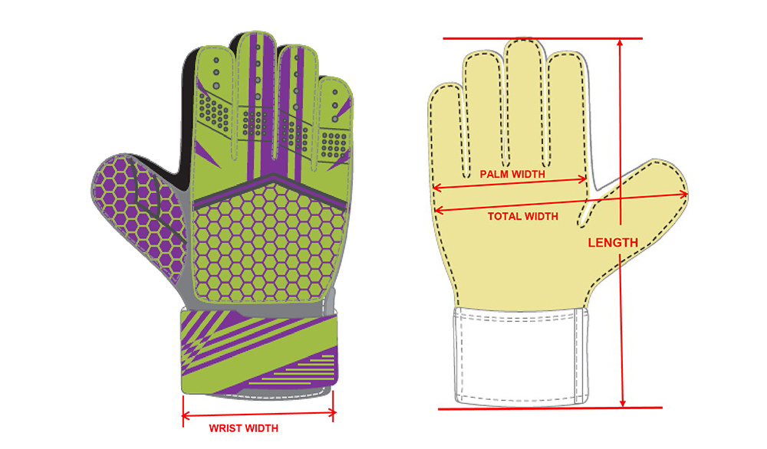

טבלת המידות מדף הבא למטה..

| **Size** | **Length** | **Palm Width** | **Total Width** | **Wrist Width** | **Age** |
| --- | --- | --- | --- | --- | --- |
| 4 | 23±0.5 cm | 9±0.3 cm | 15±0.5 cm | 6.2±0.2 cm | 6-7 years |
| 5 | 24±0.5 cm | 9.5±0.3 cm | 15.5±0.5 cm | 6.8±0.2 cm | 8-9 years |
| 6 | 25±0.5 cm | 10±0.3 cm | 16±0.5 cm | 7.2±0.2 cm | 10-11 years |
| 7 | 26±0.5 cm | 10.5±0.3 cm | 16.5±0.5 cm | 7.6±0.2 cm | Large kid or youth |
| 8 | 27±0.5 cm | 11±0.3 cm | 17±0.5 cm | 8±0.2 cm | Small to medium adult |
| 9 | 28±0.5 cm | 11.5±0.3 cm | 17.7±0.5 cm | 8.3±0.2 cm | Medium to large adult |
| 10 | 29±0.5 cm | 12±0.3 cm | 18.4±0.5 cm | 8.7±0.2 cm | Large to extra large adult |
| 11 | 30±0.5 cm | 12.5±0.3 cm | 19±0.5 cm | 9.5±0.2 cm | Extra large adult |